**STUDENT RECORD MANAGEMENT SYSTEM**

**Computer Programming 2**

**Presented by:**

Magsino, Gino Ben

**Presented to:**

Prof. Christian Michael Mansueto

*Subject Adviser*

**January 2020**

1. **OBJECTIVES**
2. Create a program with a user-friendly interface.
3. Develop a program that stores student’s record which can be accessed or modified anytime.
4. Effectively apply the lessons learned in Computer Programming 1.
5. **PROJECT DESCRIPTION**

Student Records Management System is a program designed to store, administer and manage student information. This program can add student records (ID, Name and Grade) as well as removing or modifying them. The current program can only hold up to five students records but this limitation can be adjusted by the developer. The developer used Java programming language, Java Development Kit (JDK) Version 13.0.1 and Eclipse Java as its Integrated Development Environment (IDE). The program uses MySQL Version 8.0.18 as its database and is only connected on the device’s localhost. The program was made as a requirement in Computer Programming 2.

1. **CONCEPTS/TOPICS APPLIED**
2. **While Loop**

* Used to iterate on student records to show them on table. It was also used on the main method to make a loop after every function is executed unless the exit button is pressed.

1. **If/else Statement**

* To perform actions based on different conditions on the program. It is the most used topic and is mainly applied to show whether the Student ID that was entered exists on the database.

1. **Switch Statement**

* A control statement that allows execution which corresponds to the given value. It was only used on main method to execute multiple methods quickly.

1. **JTable**

* To organize data which has both rows and columns and display it in tabular form.

1. **JScrollPane**

* Used to scroll through different data from JTable.

1. **JOptionPane**

* To display information or get inputs from user through dialog boxes.

1. **User Defined Function**

* Used in creating different types of function on the program that helps shorten the code.

1. **MySQL**

* A database management system that was used by the developed java program.

1. **SAMPLE TEST DATA**
2. **ADDING A STUDENT RECORD**

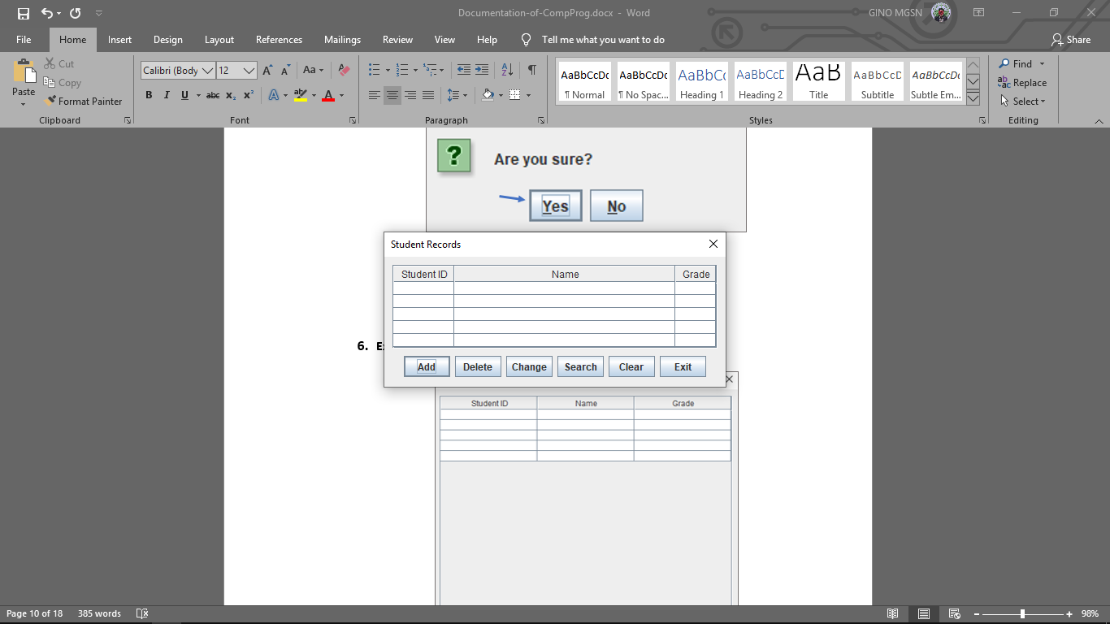

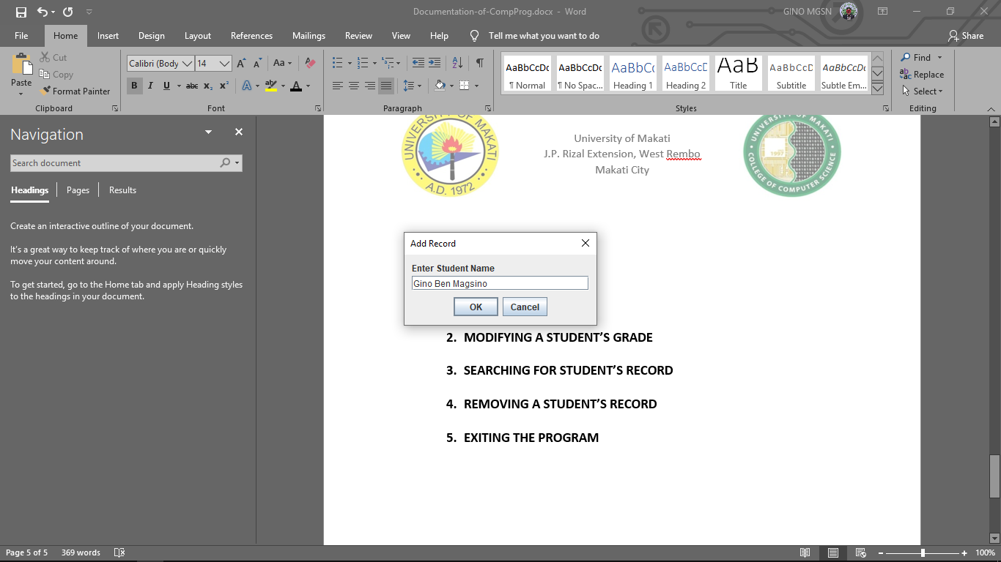

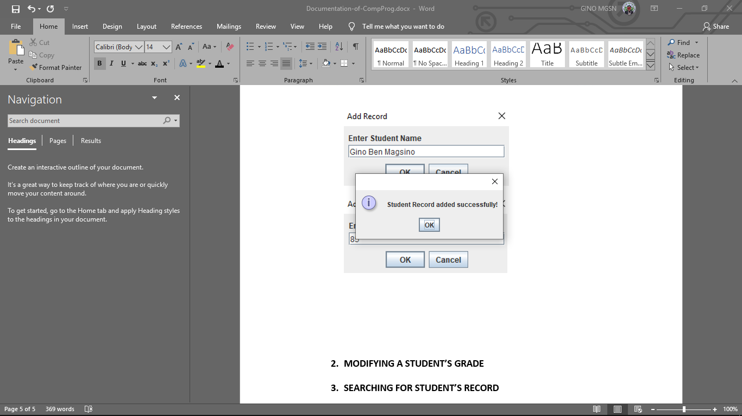

1. **REMOVING A STUDENT’S RECORD**

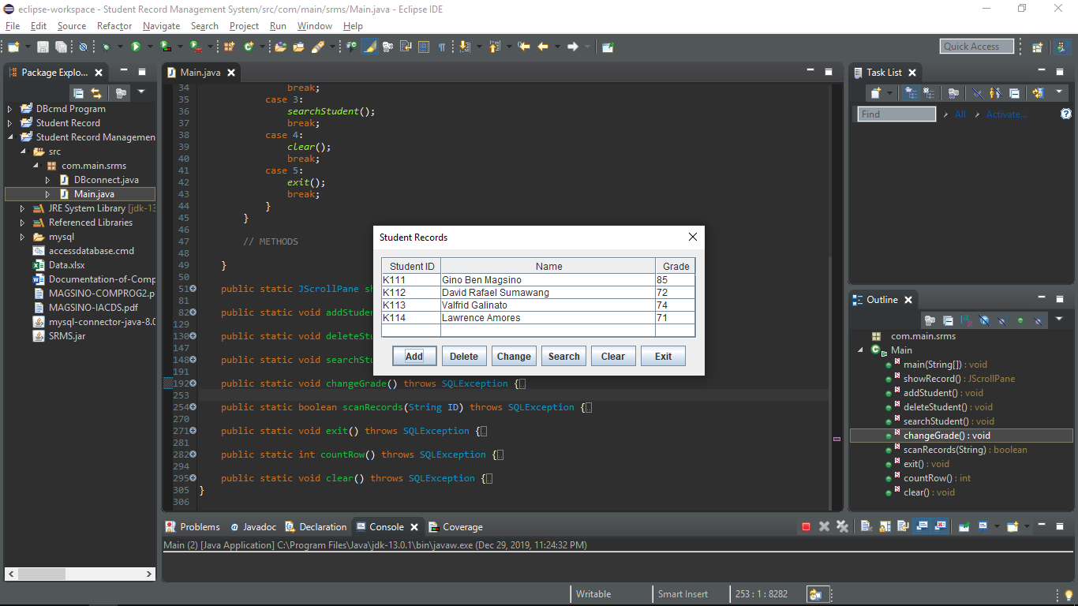

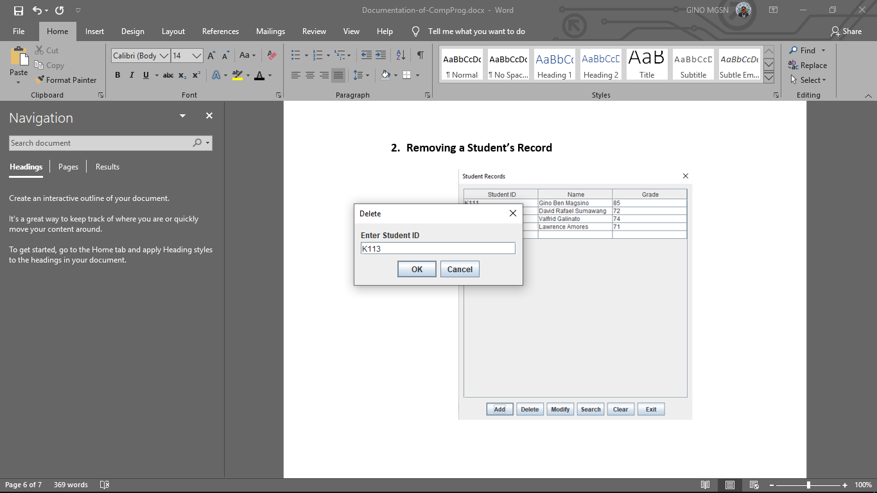

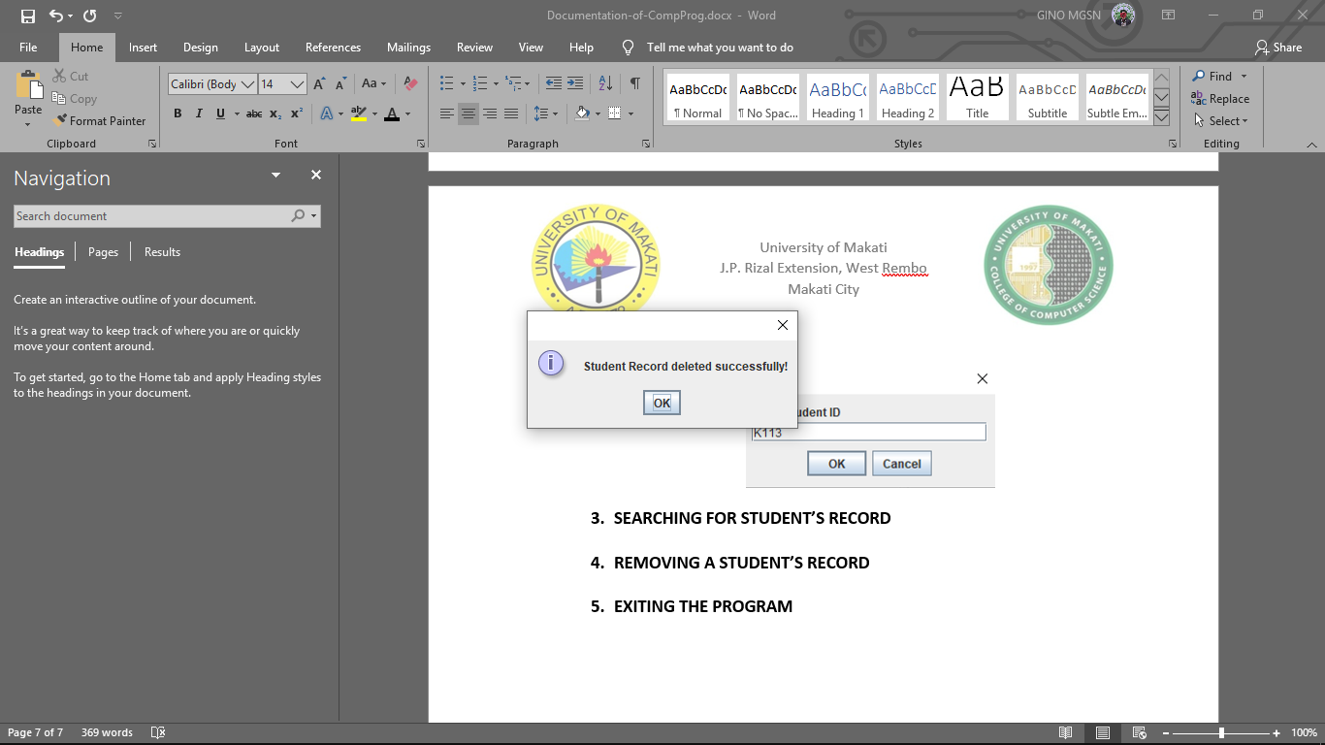

1. **SEARCHING FOR STUDENT’S RECORD**



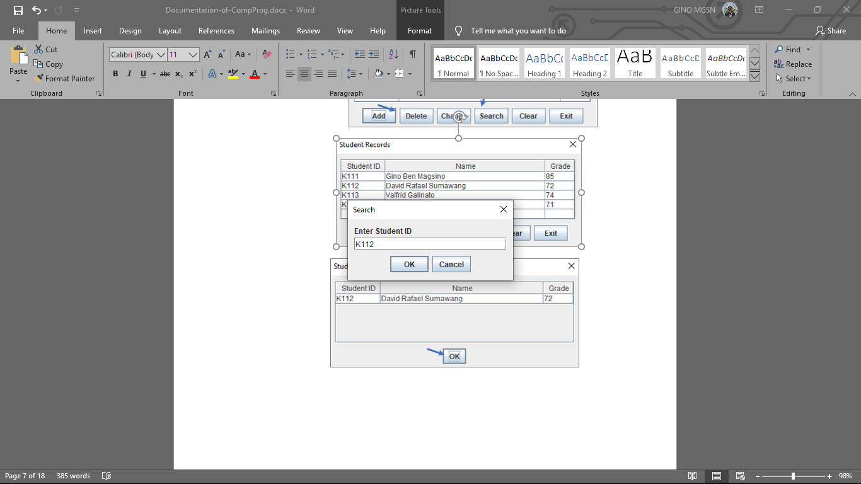

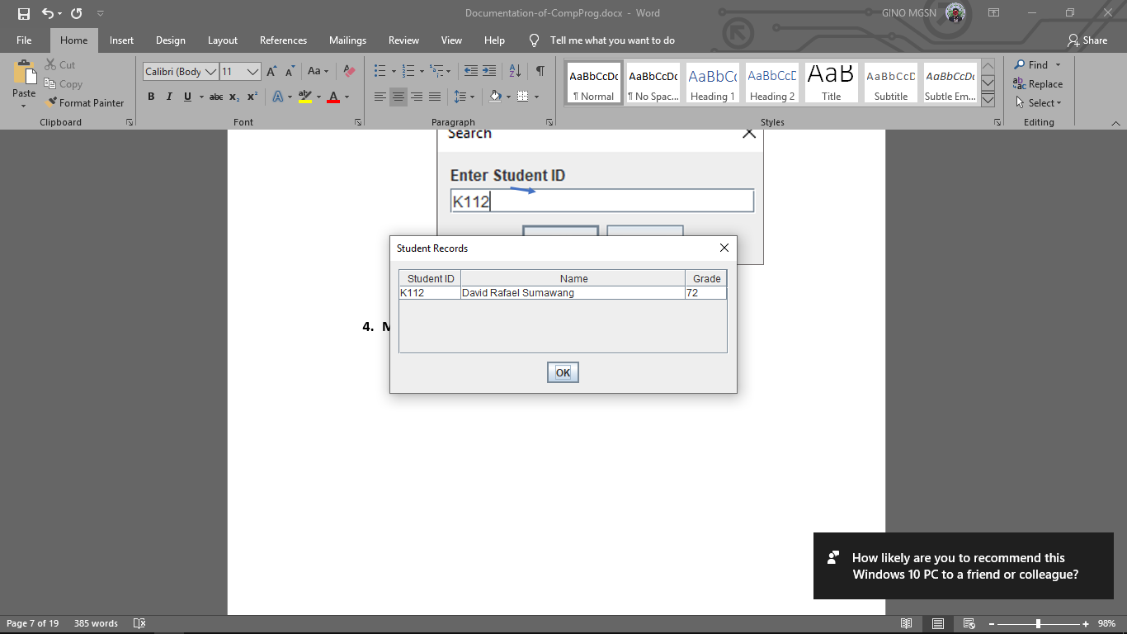

1. **CHANGING A STUDENT’S GRADE**



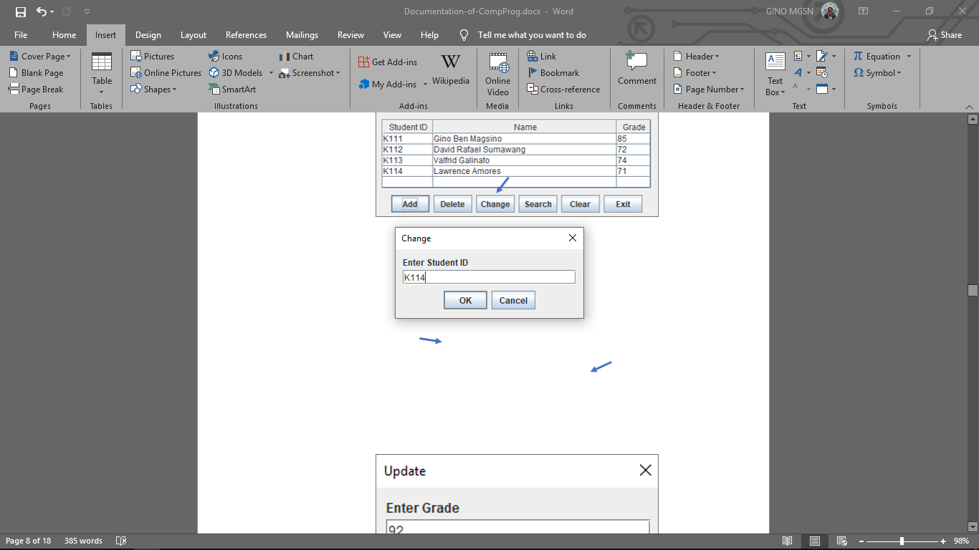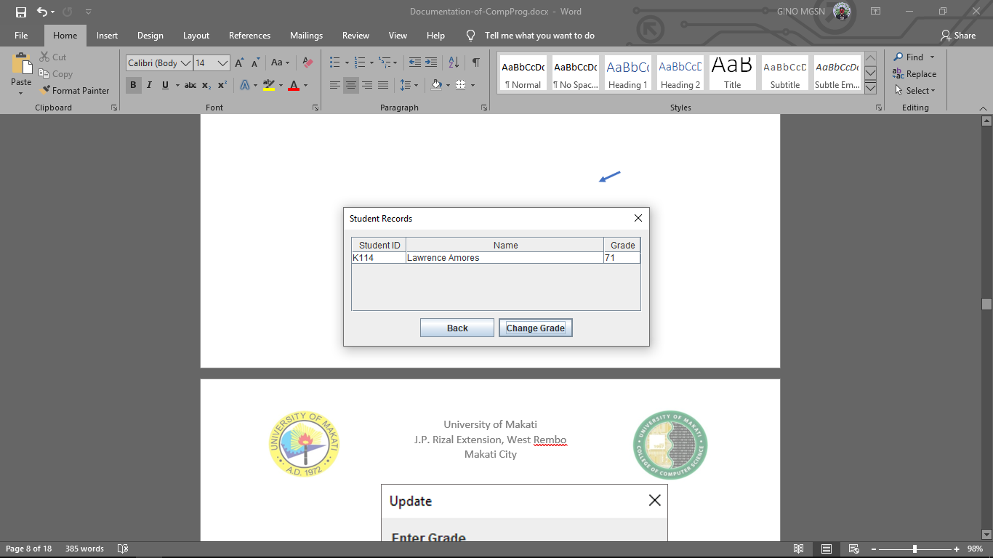

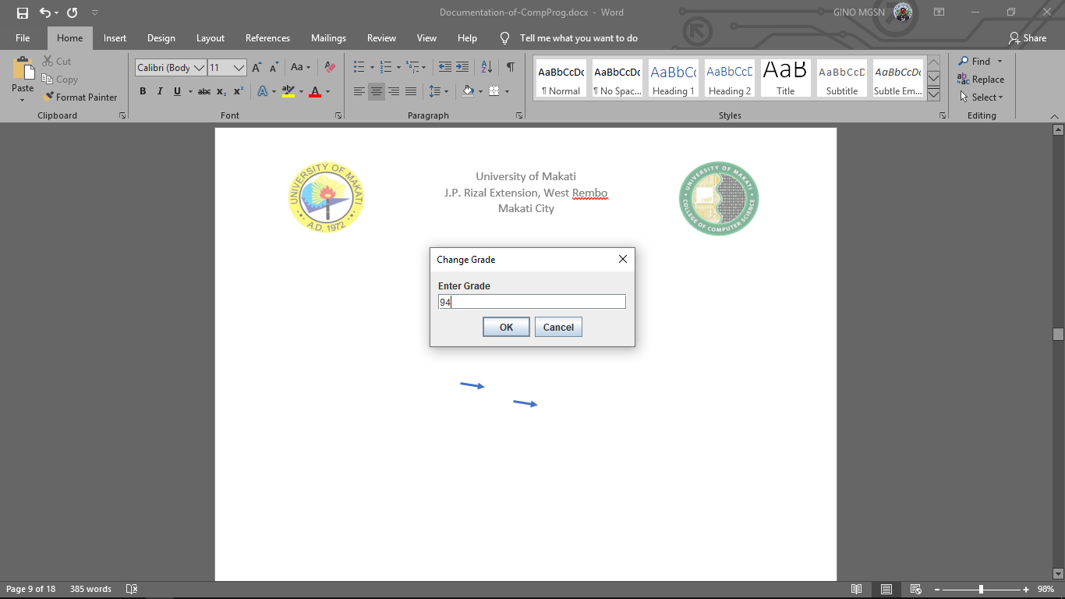

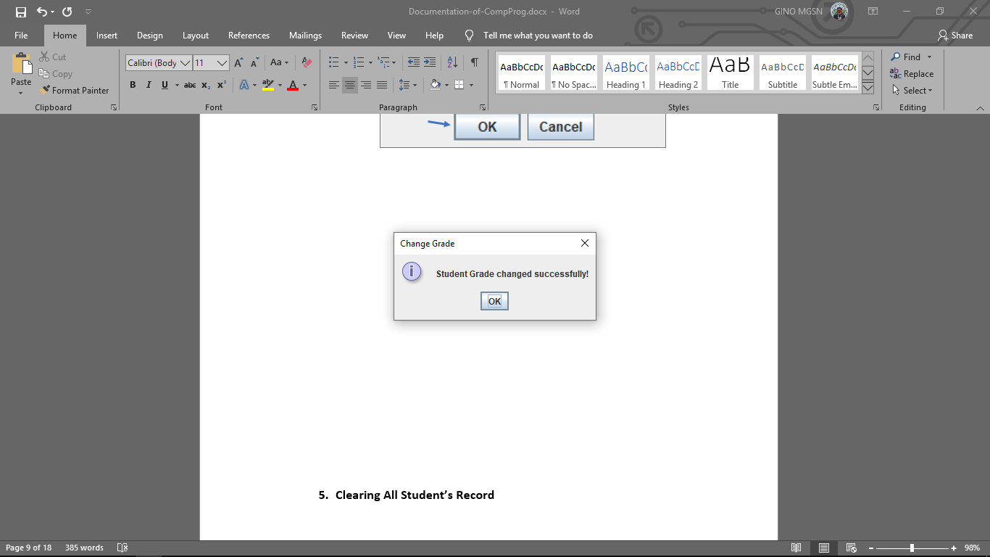

1. **Clearing All Student’s Record**

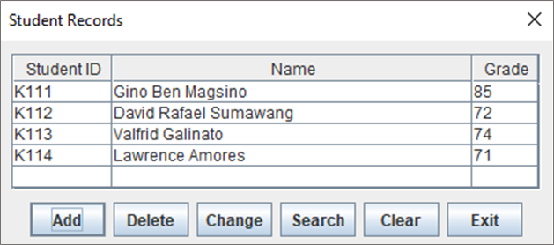

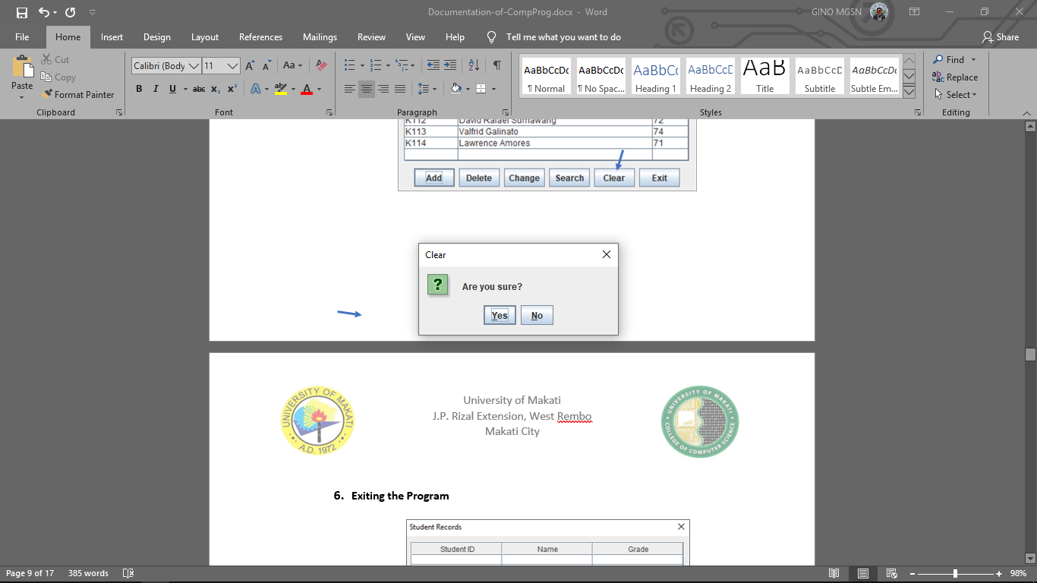



1. **Exiting the Program**



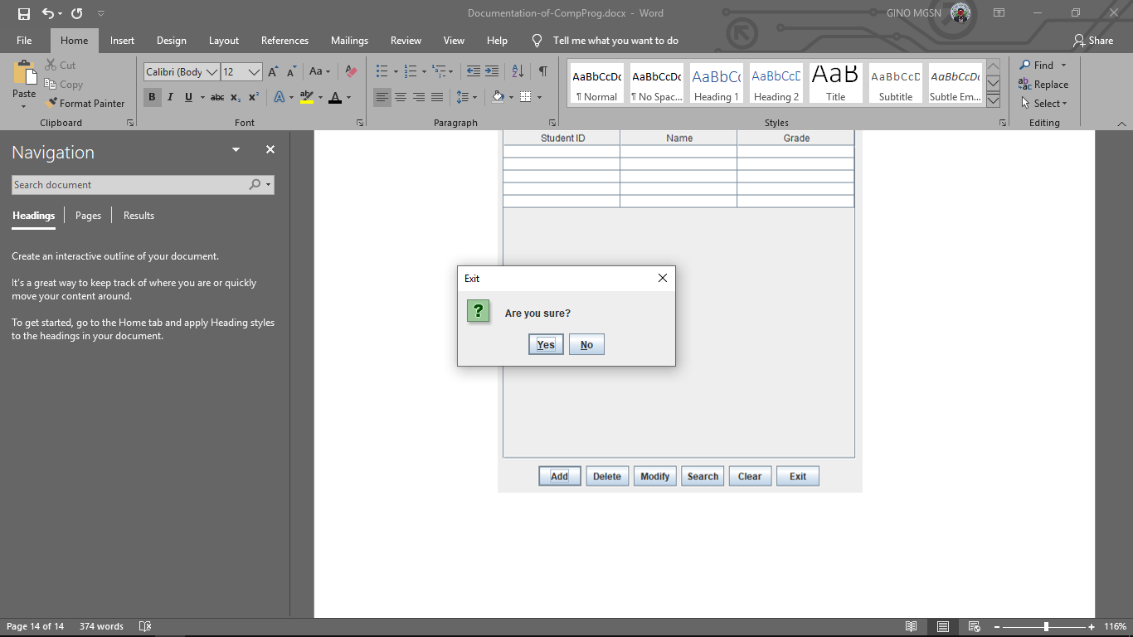

1. **PROGRAM LISTING**
2. 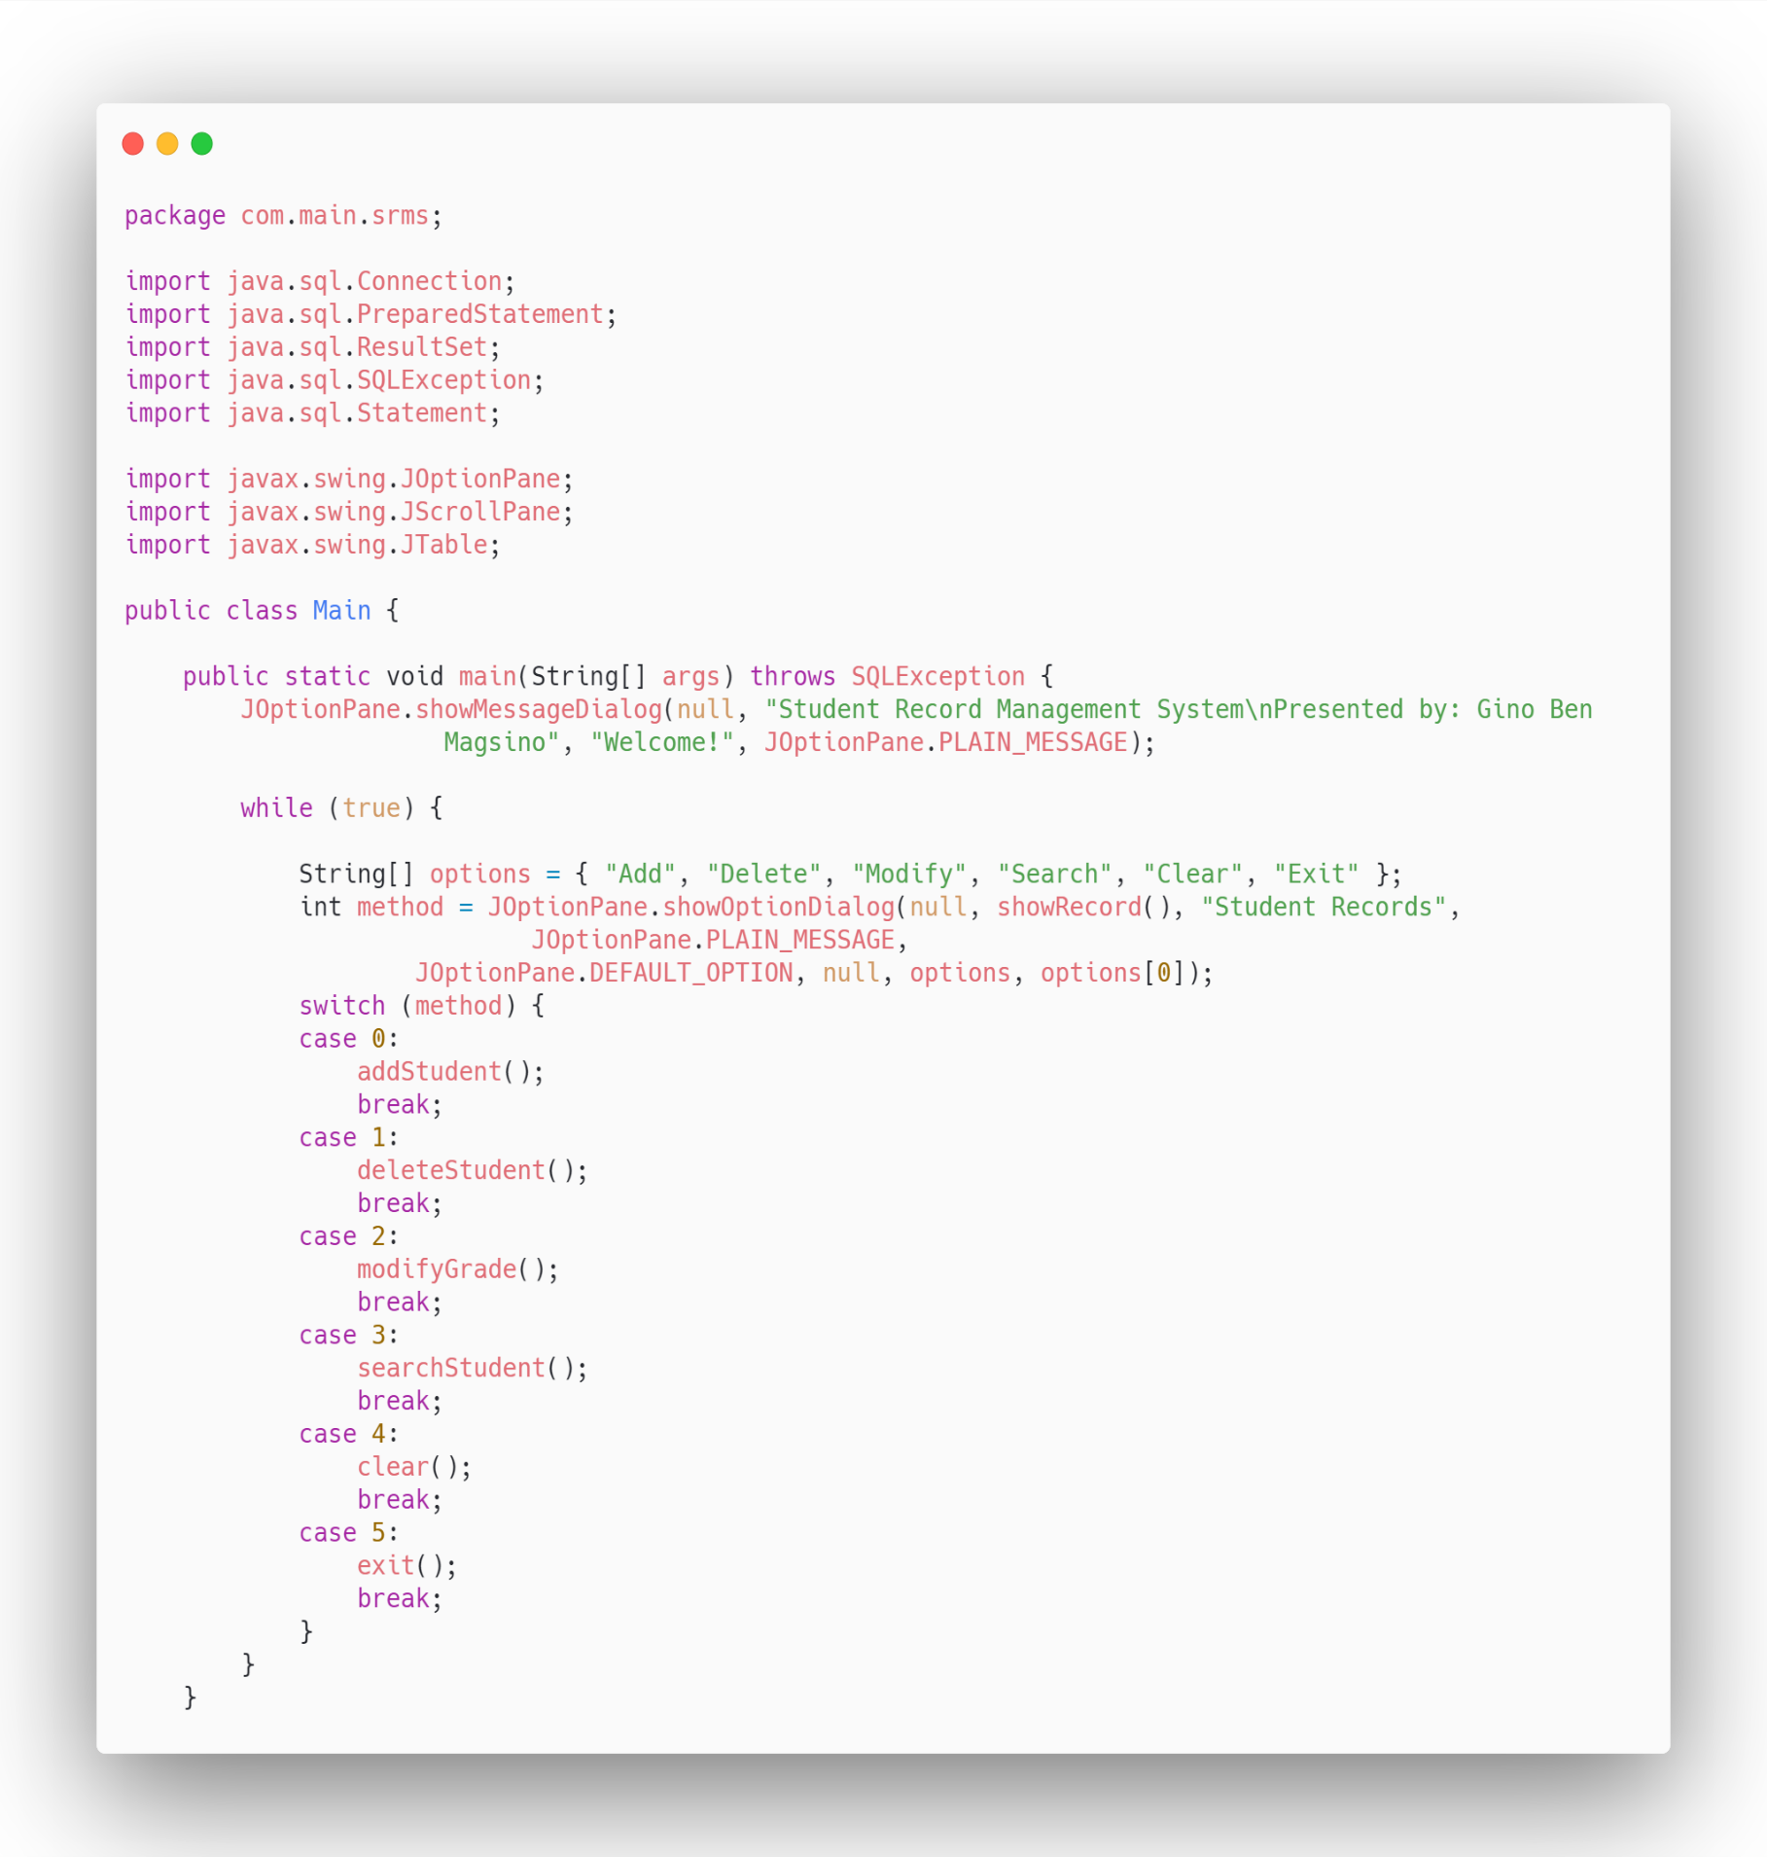Main.class

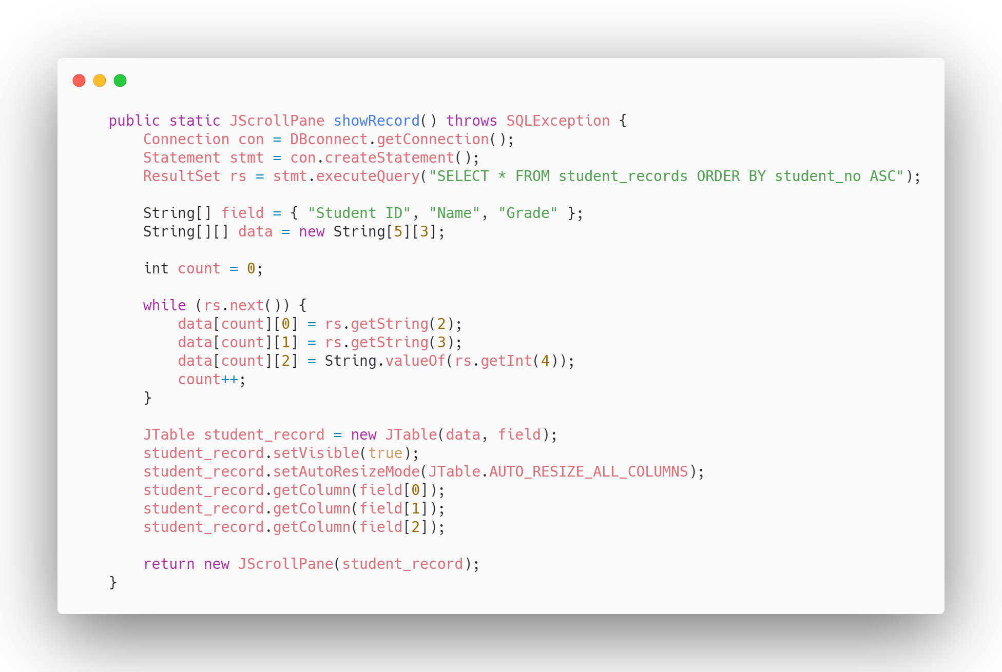

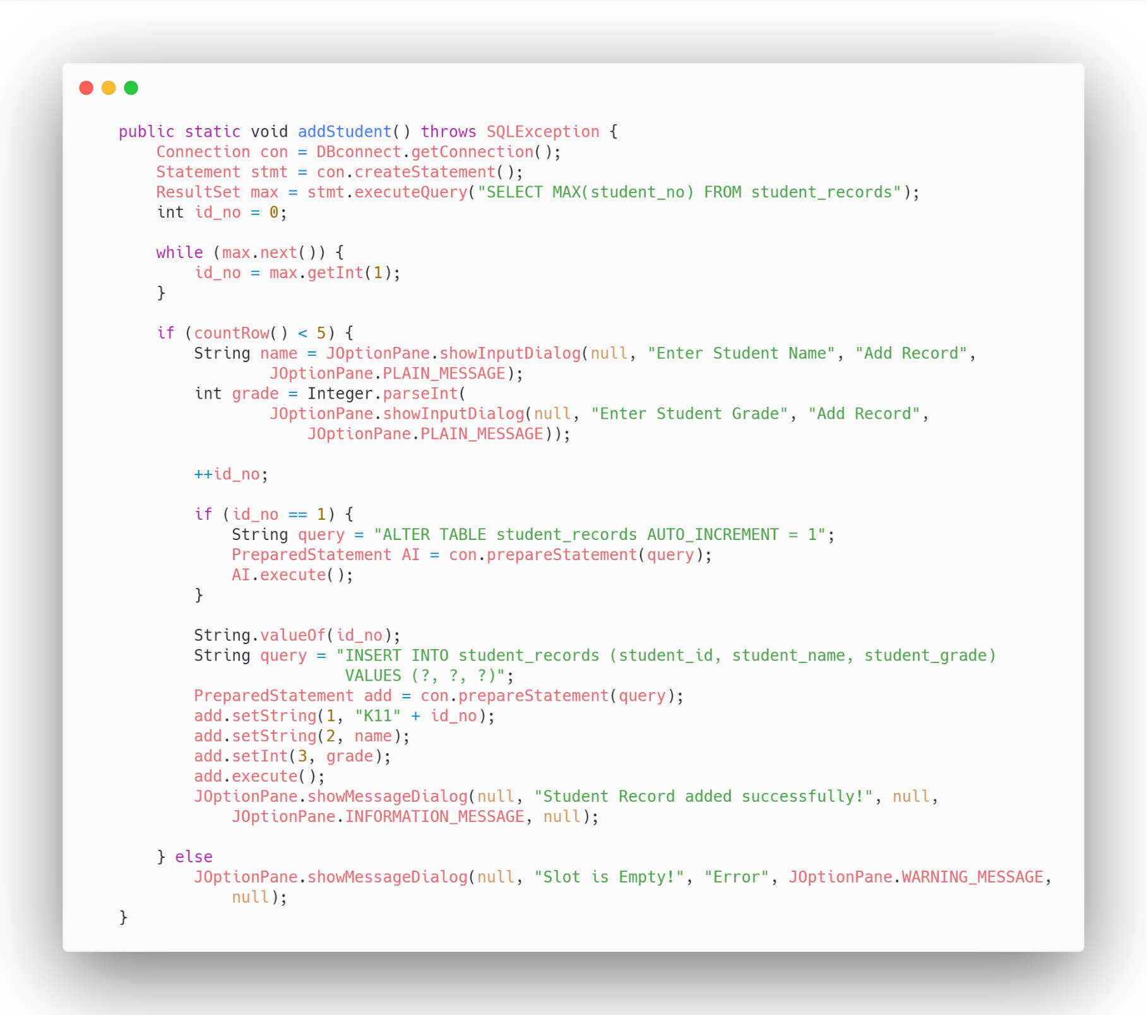

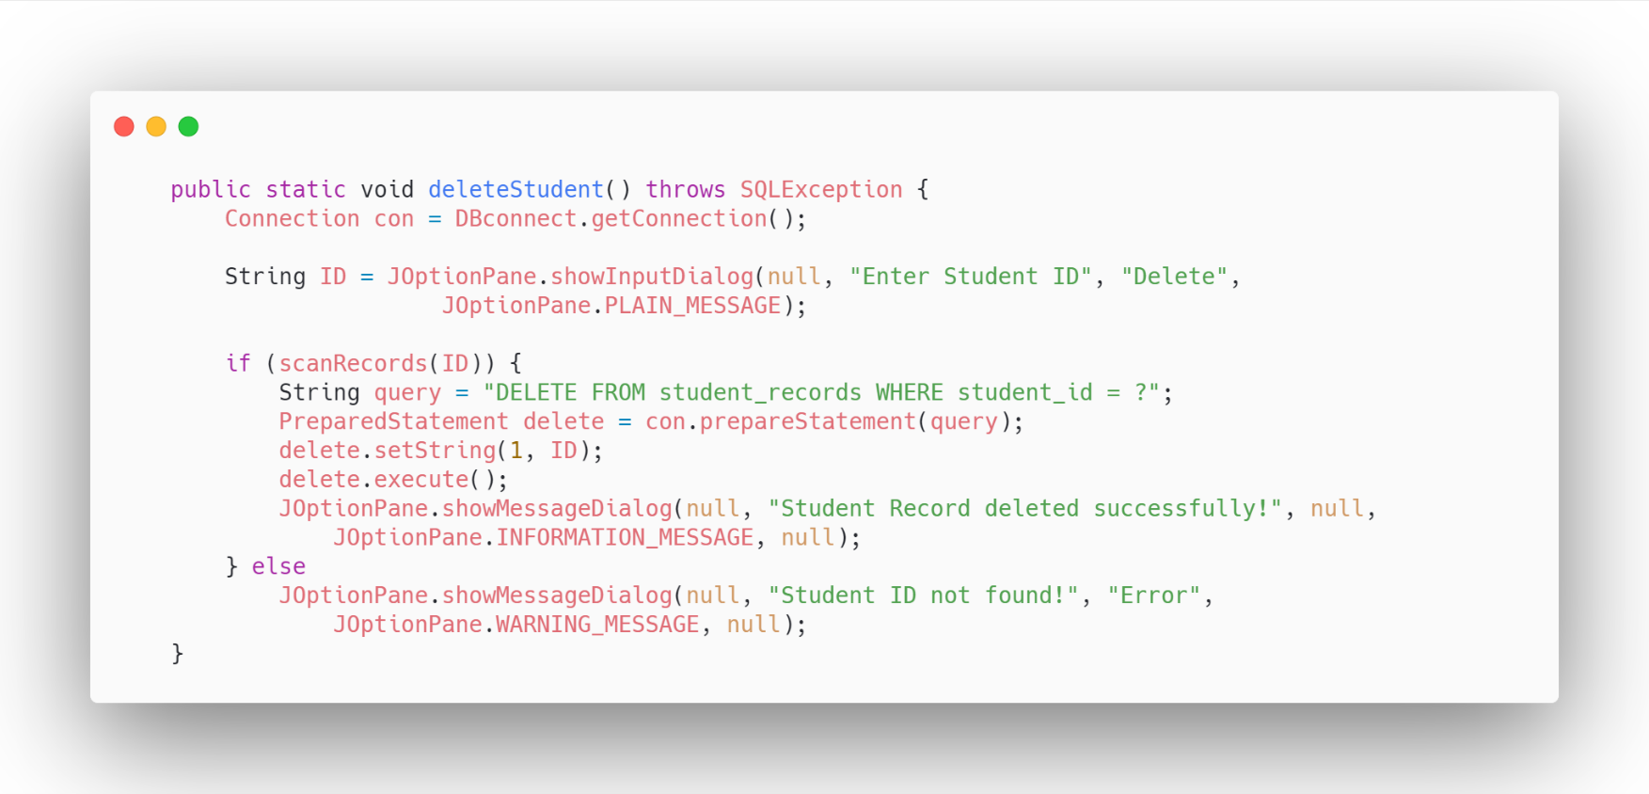

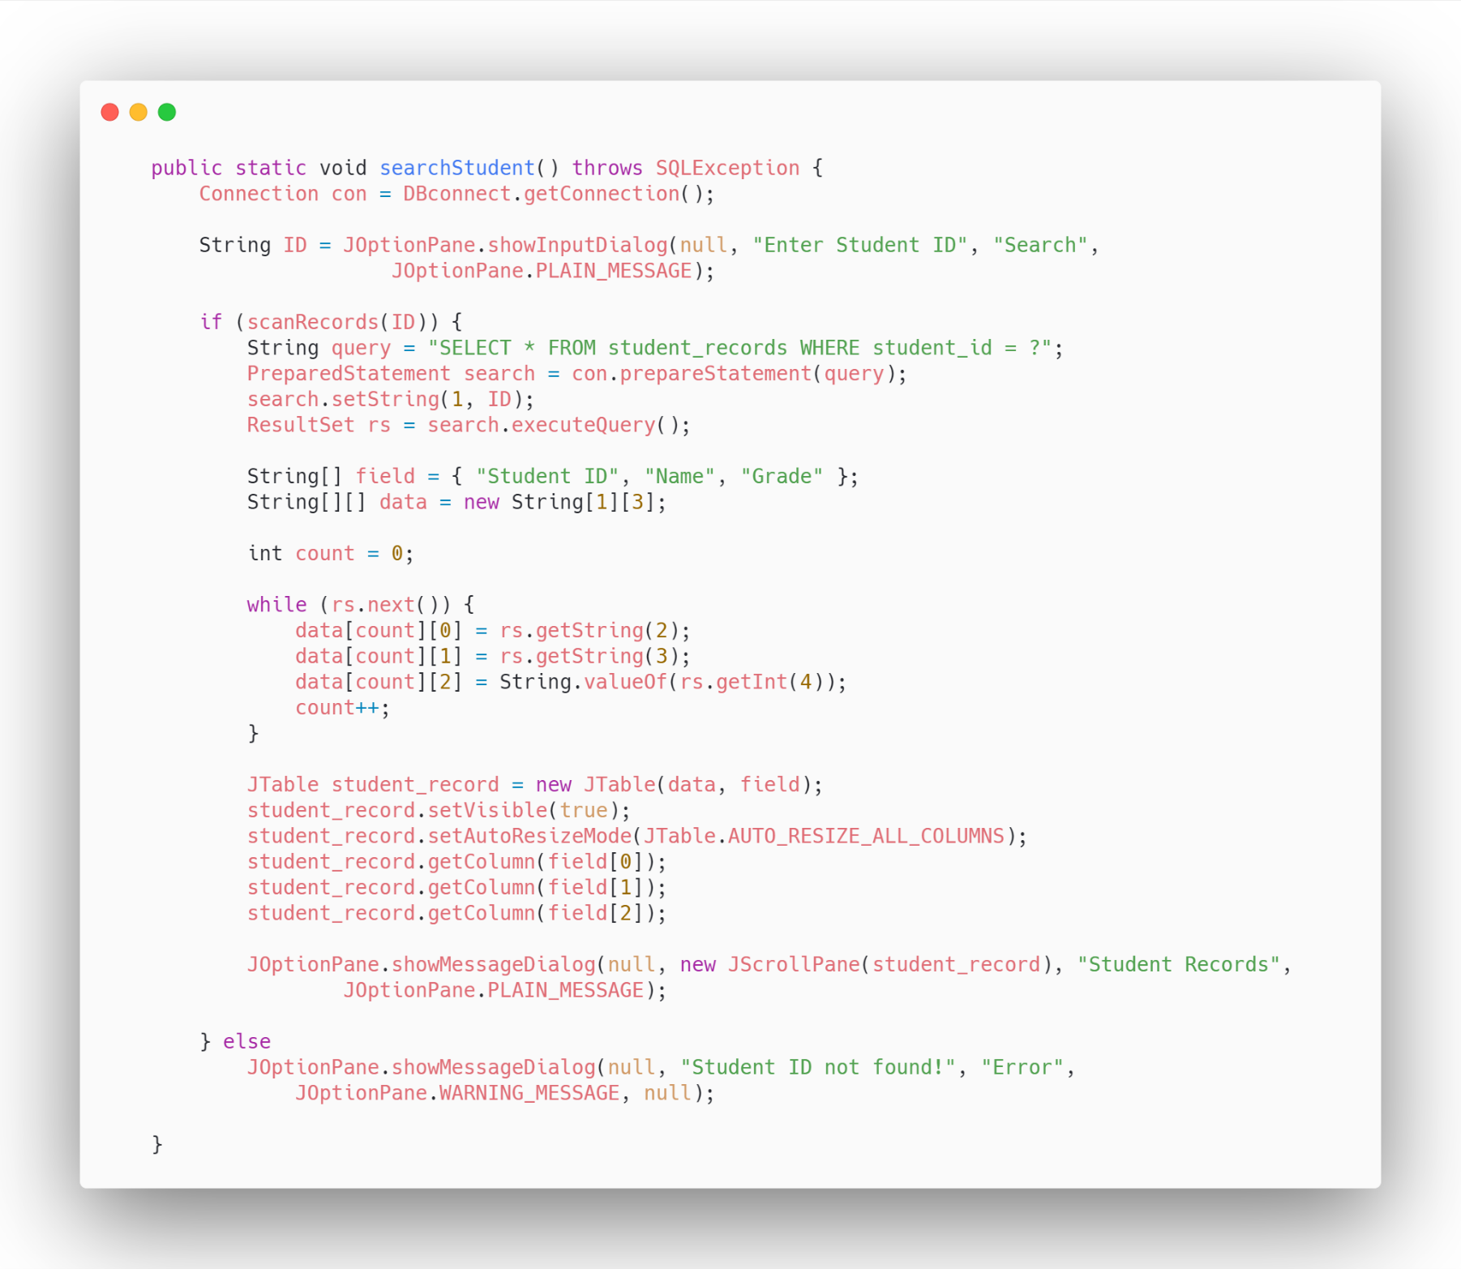

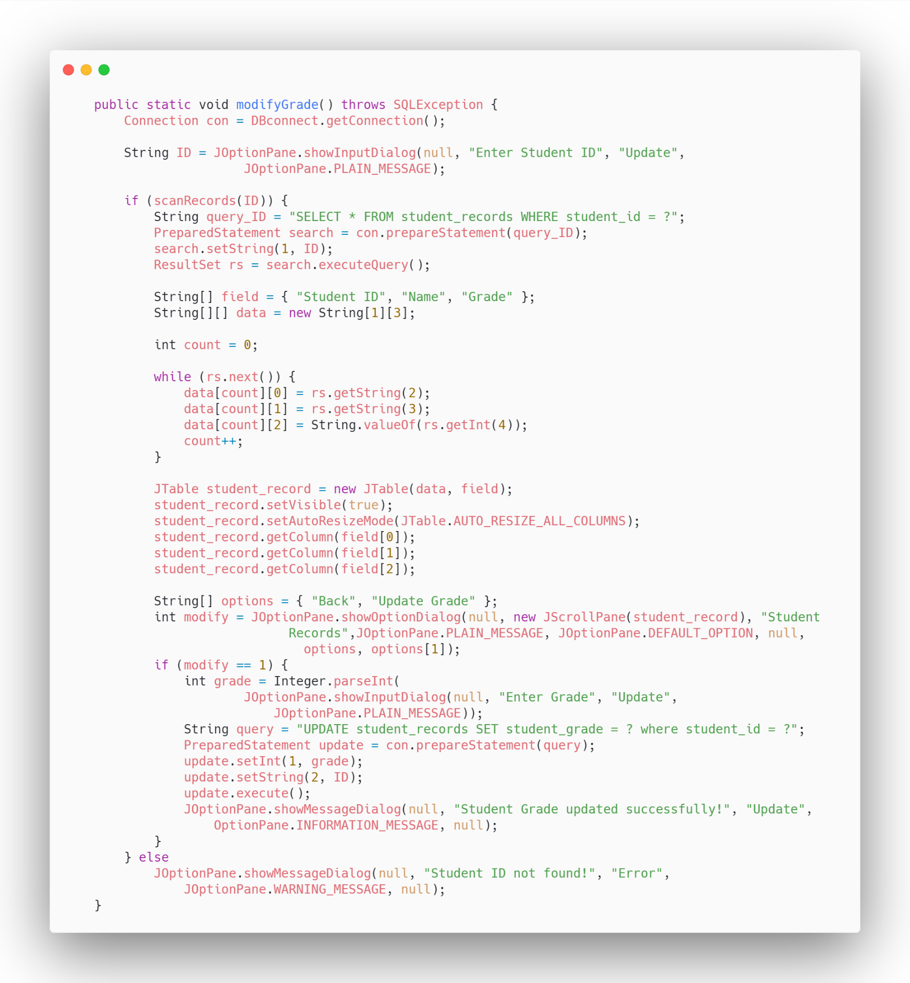

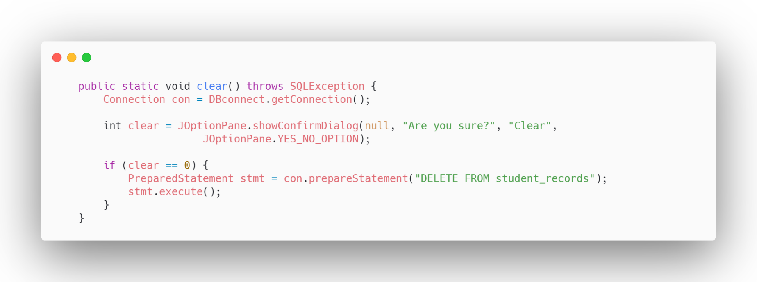

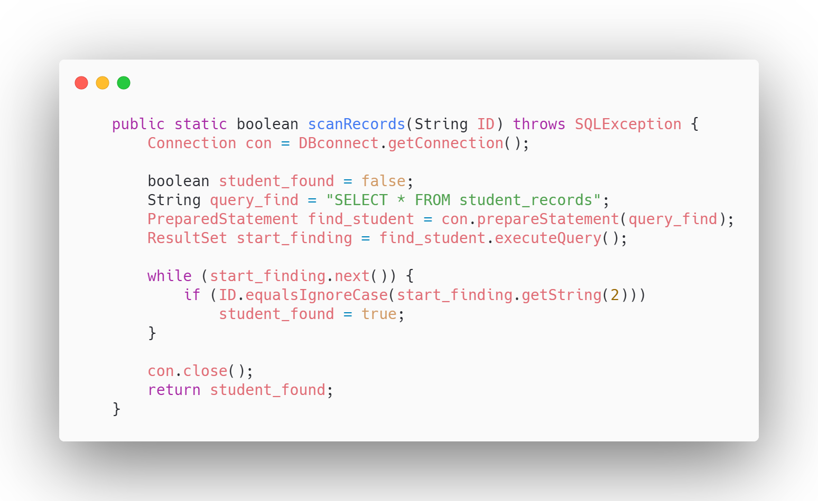

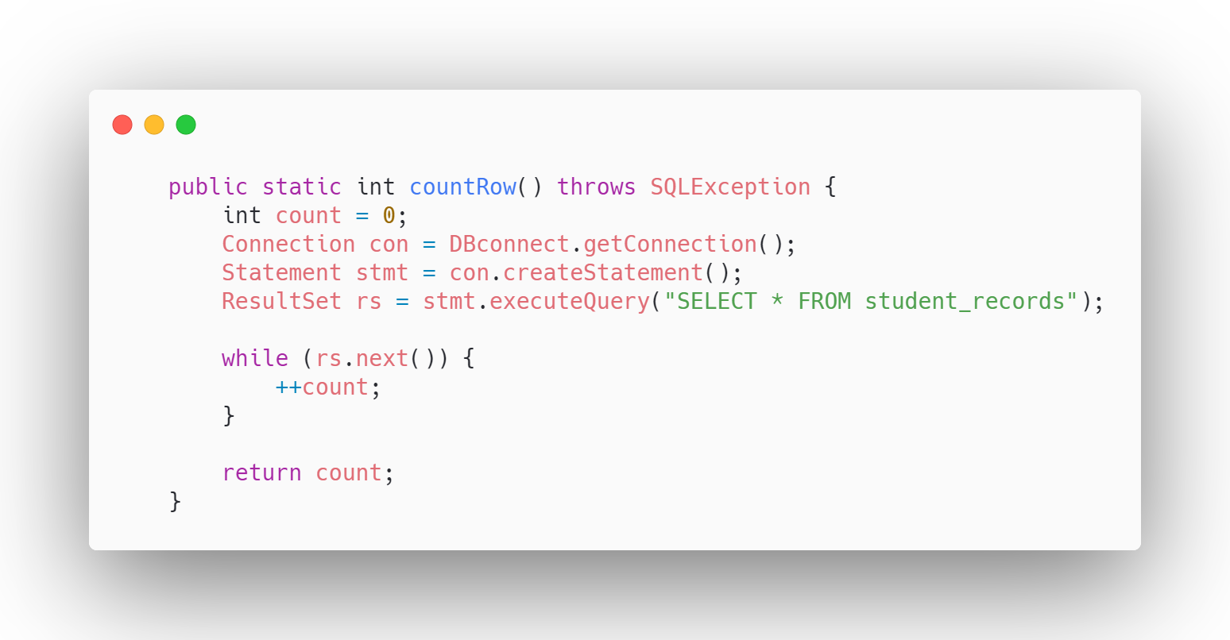

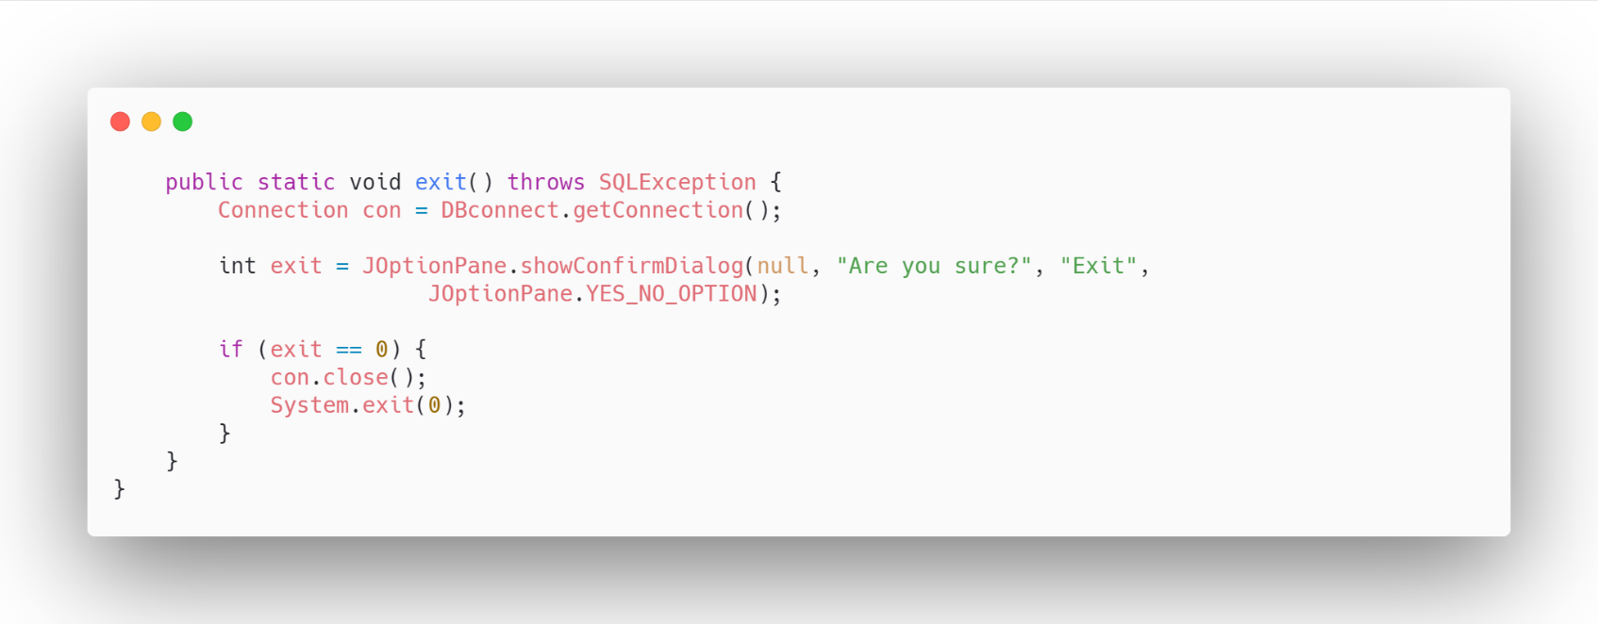

1. DBConnect.class

